Antonia Pocock

56 Cheever Place, 3rd floor  
Brooklyn, NY 11231

[antoniapocock@gmail.com](mailto:antoniapocock@gmail.com)

**PHILLIPS, DUNCAN (1886–1966) Word Count: 525**

Art collector Duncan Phillips founded one of the first museums in the United States devoted to modern European and American art. Incorporated in 1918 and opened to the public in 1921, the Phillips Collection predated the Museum of Modern Art (established 1929) and the Whitney Museum of American Art (established 1931). It was housed in Phillips’ childhood home, an 1897 Georgian Revival house in the Dupont Circle neighborhood of Washington D. C. After graduating from Yale University in 1907, Phillips pursued his passion for art, which he collected and wrote about for the rest of his life. The sudden deaths of his father in 1917 and older brother in 1918 prompted him to found a museum in their memory, originally called the Phillips Memorial Art Gallery. Phillips served as the museum’s director until his death in 1966, when his wife, the artist Marjorie Acker, took his place. When she died in 1972, their son, Laughlin Phillips, assumed directorship. Rather than pursuing comprehensiveness, Phillips collected in depth the works of his favorite artists, including Honoré Daumier, Pierre Bonnard, George Braque, Karl Knaths, Arthur Dove, John Marin, Oskar Kokoschka, and Paul Klee.

Motivated by a desire to educate the public about modern art, Phillips wrote and lectured extensively on the topic. Shortly after college, hecontributed essays and reviews to *Art and Progress,* *Scribner’s,* and the *Yale Review*. In 1914, he published his first book, *The Enchantment of Art,* which he revised in 1927 to account for a marked change in his taste. In 1913, he was among the conservative critics of the Armory Show, rejecting Post-Impressionism, Fauvism and Cubism. When he began collecting art in 1916 with an allowance from his parents, he acquired works by artists associated with Tonalism and American Impressionism, including George Inness, John Henry Twachtman, J. Alden Weir, and Childe Hassam. Between 1918 and 1921, he bought paintings by French Impressionist Claude Monet, French caricaturist Honoré Daumier, and American Aschan school painters George Luks and Robert Henri. Over the course of the 1920s, however, he began collecting increasingly abstract works by the French and American avant-garde artists he initially rejected, such as Henri Matisse, Pablo Picasso, and Georgia O’Keeffe. By the 1950s, he was actively collecting leading American abstractionists of that decade, including Willem de Kooning, Mark Rothko, Morris Louis, and, Kenneth Noland. Phillips embraced a broad definition of ‘modernism,’ a term he applied to every artist in his collection from Giorgione to Rothko, and understood as an anti-conformist mentality rather than a defined period or style. Accordingly, Phillips did not organise works in his museum by period or nationality, but preferred to emphasize the continuities amidst his diverse collection.

**References and Further Reading**

Phillips, D. (1913) “Revolutions and Reactions in Painting,” *International Studio* 51,December, 123–129. A review the Armory Show.

Phillips, D. (1926) *A Collection in the Making.* Washington, D. C.: Phillips Memorial Gallery, 1926. Available online: <https://archive.org/details/collmaki00phil>.

Turner, E. H. (1991) *Duncan Phillips Collects: Paris Between the Wars.* Washington, D.C.: The Phillips Collection.

Passantino, D. and David W. S., eds. (1999) *The Eye of Duncan Phillips: A Collection in the Making.* Washington, D.C.: Phillips Collection in association with Yale University Press, New Haven.

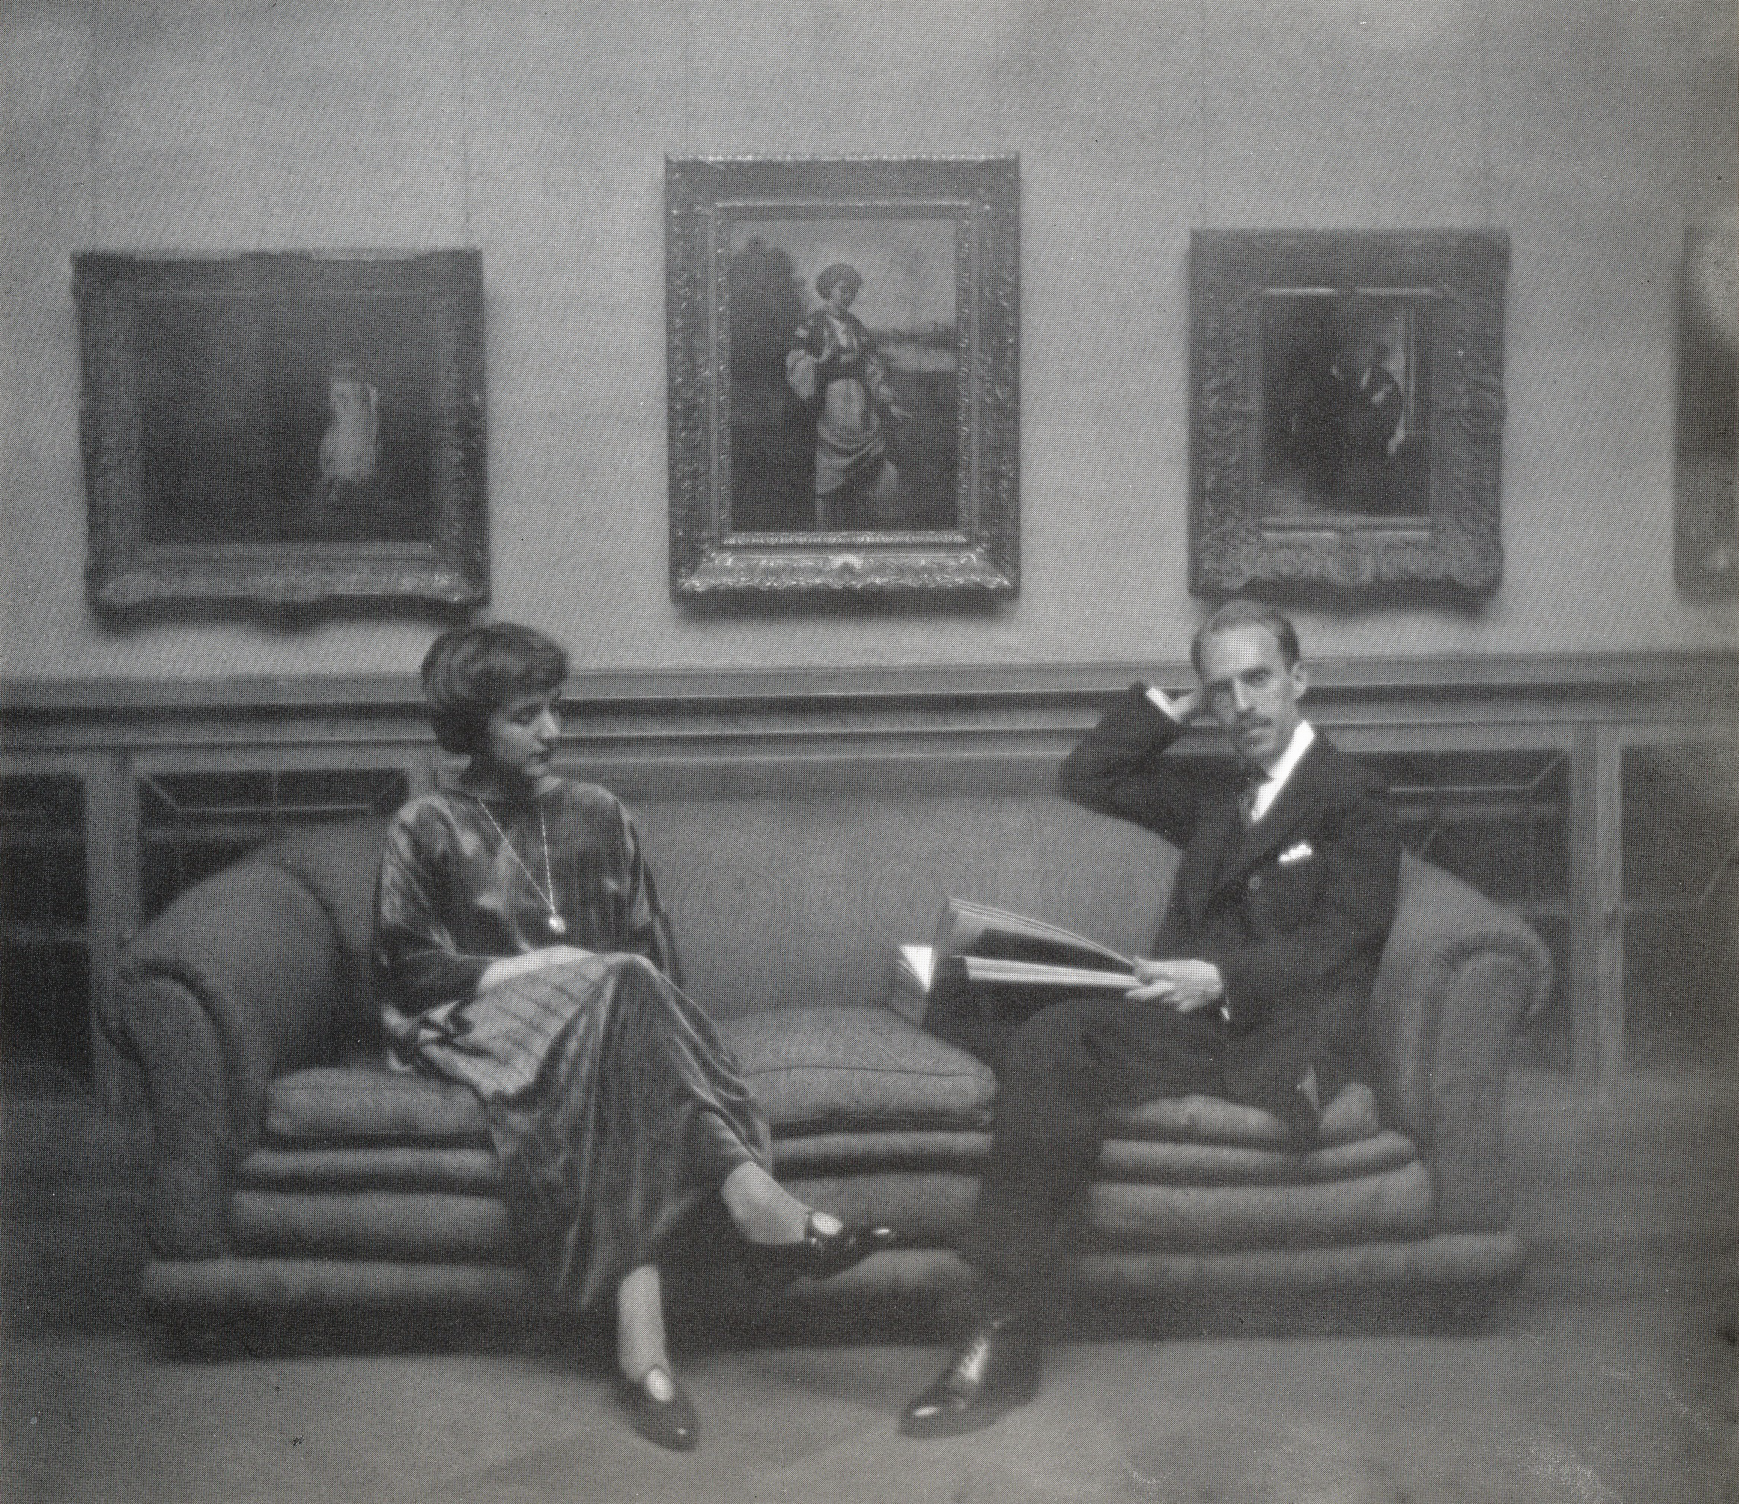

Clara Sipprel, *Marjorie and Duncan Phillips in the Main Gallery,* c. 1922.

**[Photograph scanned from: Ruth W. Spiegel, ed., *The Phillips Collection In the Making: 1920–1930* (Washington, D. C.: The Phillips Collection and the Smithsonian Institution, 1979), 8. Copyright page notes that all photographs are reproduced courtesy of the Phillips Collection. For questions regarding rights and reproductions, email: imagerights@phillipscollection.org. For further information on how to obtain permission for reproduction, visit:** [**http://www.phillipscollection.org/collection/rights-and-reproductions/index.aspx**](http://www.phillipscollection.org/collection/rights-and-reproductions/index.aspx)**]**